Finding AR books on Libraries NI.

Go to https://librariesniuk.overdrive.com/ and log in using your child’s library number from their library card.

Go to Search – Advanced Search
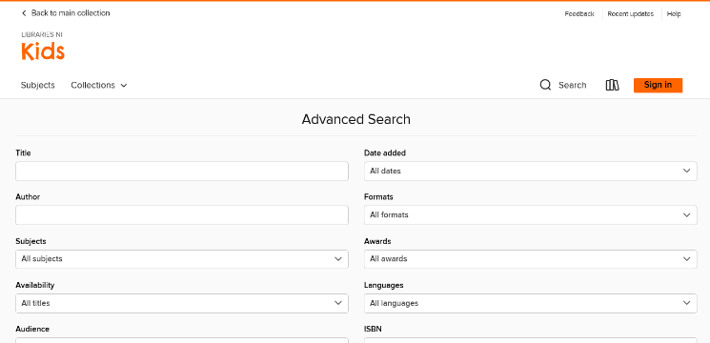

Scroll down to
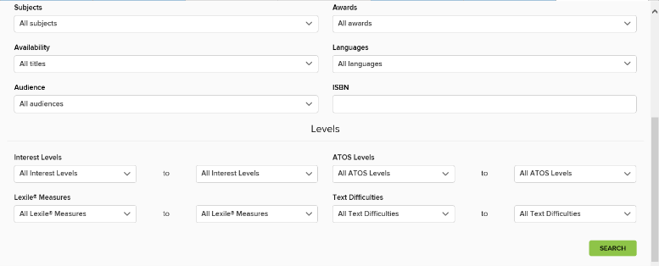

Change ATOS level to your child’s AR book level and click search.
A list of books will come up. Click borrow for your child to access the book.
