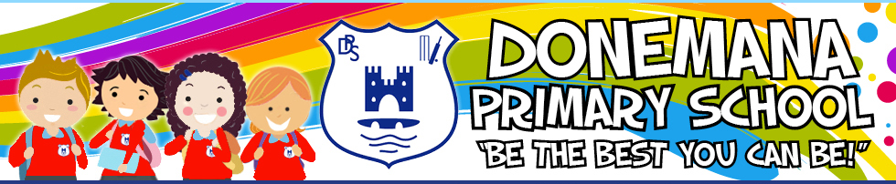

www.donemanaps.com 02871398633 Principal: Mrs G Hay B.Ed. (Hons.) PQH

Dear Parent

We are a PATHS® School
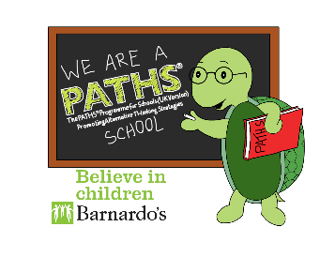
From September, we have been implementing an exciting new PDMU linked programme, PATHS® with all classes and throughout our school community.

PATHS® stands for Promoting Alternative Thinking Strategies and is a highly recognised and evidence-based programme which is designed to facilitate the development of self-control, emotional awareness and interpersonal problem-solving skills.

To help support us in the whole school implementation of PATHS®, we have our very own PATHS® Coach, Lindsay Mc Sparron from Barnardo’s NI. Lindsay visits us throughout the year and works alongside our teachers, classroom assistants, lunchtime supervisors and pupils.

For your opportunity to find out more, we have planned to hold a Parents’ Information Session on

Thursday 4th April from 1:30 to 2:45pm at St Patrick’s PS, Donemana.

Our PATHS® coach will be leading this session in sharing the PATHS® strategies, curriculum teaching and benefits of this programme.

To find out more in the meantime you can visit the PATHS® UK website: www.pathseducation.co.uk of follow PATHS UK on Facebook: @pathseducationuk and Twitter Feed: @PATHSEdUK

Kind regards

Mrs G Hay
(Principal)

